Cosmetic Insights : Navigating Cosmetics Trends and Consumer Insights with Tableau

1.INTRODUCTION

**1.1 Project Overview**

**Cosmetic Insights** is a data visualization project built with **Tableau** that explores the latest trends and consumer behaviors in the cosmetics industry. By analyzing product sales, customer demographics, and social media influence, this project aims to uncover meaningful insights that help brands and businesses make informed, data-driven decisions.

**1.2 Purpose**

The main goals of this project are to:

* Visualize **cosmetic product trends** across different categories (skincare, makeup, haircare)
* Analyze **consumer preferences** based on demographics like age, gender, and region
* Explore the **impact of influencers and social media** on product popularity
* Provide **interactive dashboards** to support market research, brand strategy, and campaign planning
* Demonstrate how Tableau can be used to turn raw data into actionable business insights

**2. IDEATION PHASE**

**2.1Problem Statement**

* Cosmetic brands struggle to understand fast-changing consumer preferences, product trends, and regional demands. They need a clear, data-driven way to track market trends and buyer behavior to stay competitive.

2.2 **Empathy Map Canvas**

* Cosmetic brand managers
* Marketing teams
* Product developers
* Retail decision-makers
* Understand what products are trending
* Know who their customers are
* Improve product offerings and marketing strategies

2.3 **Brainstorming Ideas**

* Create dashboards showing top trending ingredients or products
* Map customer reviews to positive/negative sentiment
* Analyze product performance by age, gender, and location
* Track influencer impact on product sales

# 3. REQUIREMENT ANALYSIS

3.1 **Customer Journey Map**

Users discover cosmetics, compare products online, read reviews, and purchase through retail or e-commerce, influenced by trends and social media.  
Post-purchase, they leave feedback, follow brands, and seek personalized product recommendations.

**3.2 Solution Requirements**

* Clean, structured datasets (sales, reviews, demographics).
* Interactive Tableau dashboards with filters, visual charts, and insights.

**3.3 Data Flow Diagram**

Raw data (sales, reviews, customer info) → Data cleaning/preparation → Tableau dashboards → User interaction & insights.

**3.4 Technology Stack**

* **Tableau** for data visualization
* **Excel/CSV** for data input
* *(Optional)* **Python/Power Query** for data cleaning and preprocessing

# 4. PROJECT DESIGN

### **4.1 Problem-Solution Fit**

Cosmetic brands struggle to keep up with changing trends and customer preferences.  
This project provides data-driven insights through visual dashboards to guide smarter decisions.

### 4.2 **Proposed Solution**

Use Tableau to create interactive dashboards that analyze product trends, consumer behavior, and market performance.  
This helps brands identify what’s working and where to focus marketing and product efforts.

**4.3 Solution Architecture**

Data is collected from sources like sales reports, customer reviews, and social media analytics.  
The data is cleaned, processed, and visualized in Tableau for easy exploration and actionable insights.

**5. PROJECT PLANNING & SCHEDULING**

**5.1 Project Planning**

Phase | Duration

Data Collection | 1day

Data Cleaning & Prep | 1 days

Visualization Design | 1 day

Dashboard & Story Dev | 2 days

Web Integration (Flask) | 1 day

Testing & Doc Prep | 1 day

**6. FUNCTIONAL AND PERFORMANCE TESTING**

**6.1 Performance Testing**

- Visualizations optimized with filters and extracts

- Used ≤ 4 charts per dashboard

- Minimum calculated fields

- Tableau Public used to host visuals for fast load time

**7. RESULTS**

**7.1 Output Screenshots**

Include dashboard images such as:

-Top Brands

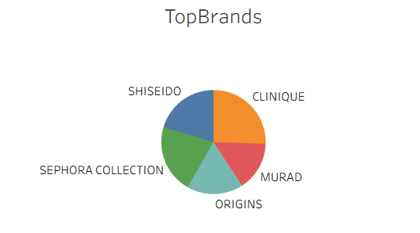

-Label Count

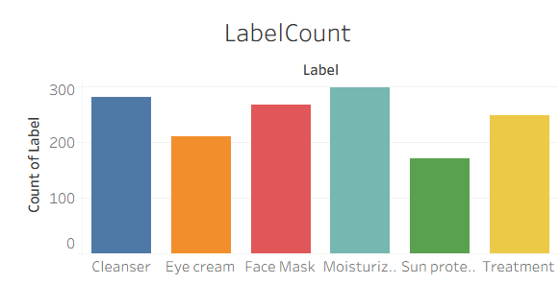

-Price vs Brand

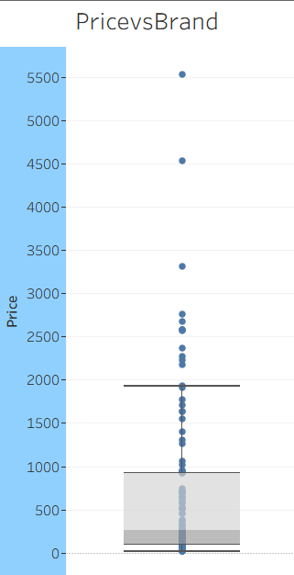

-Brand vs Rank

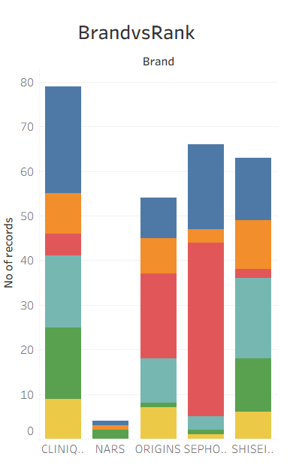

-Sensitivity skin suitability

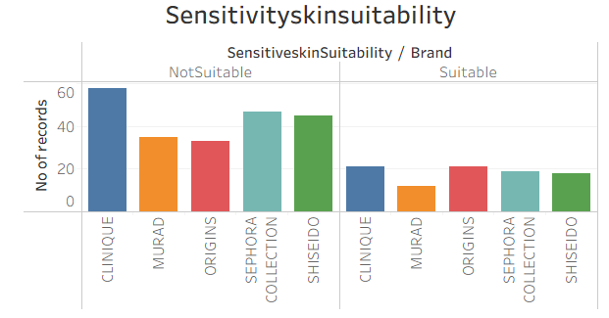

-Oil skin suitability

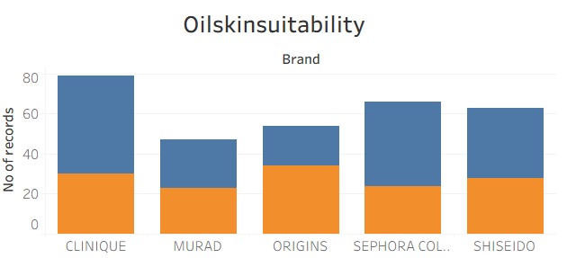

-Normal skin suitability

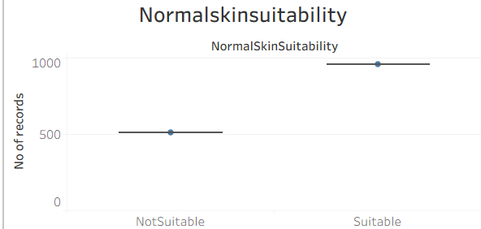

-Dry skin Suitability

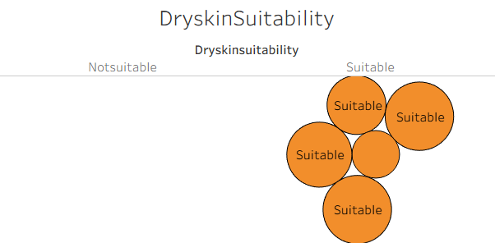

**Dash board:**

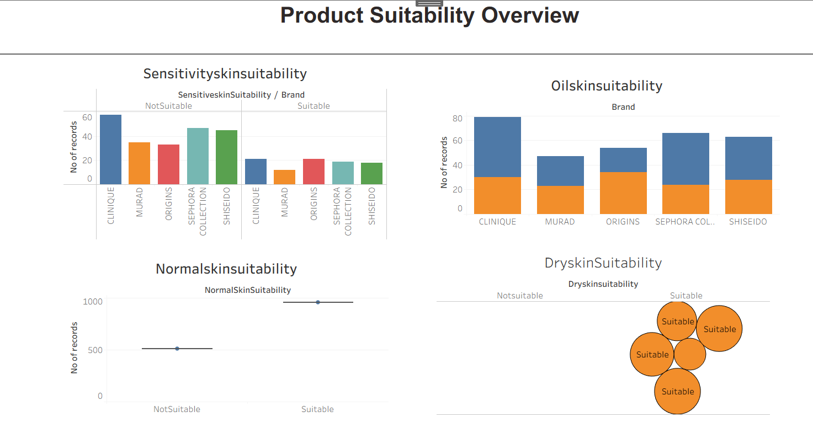

Dashboard 2:

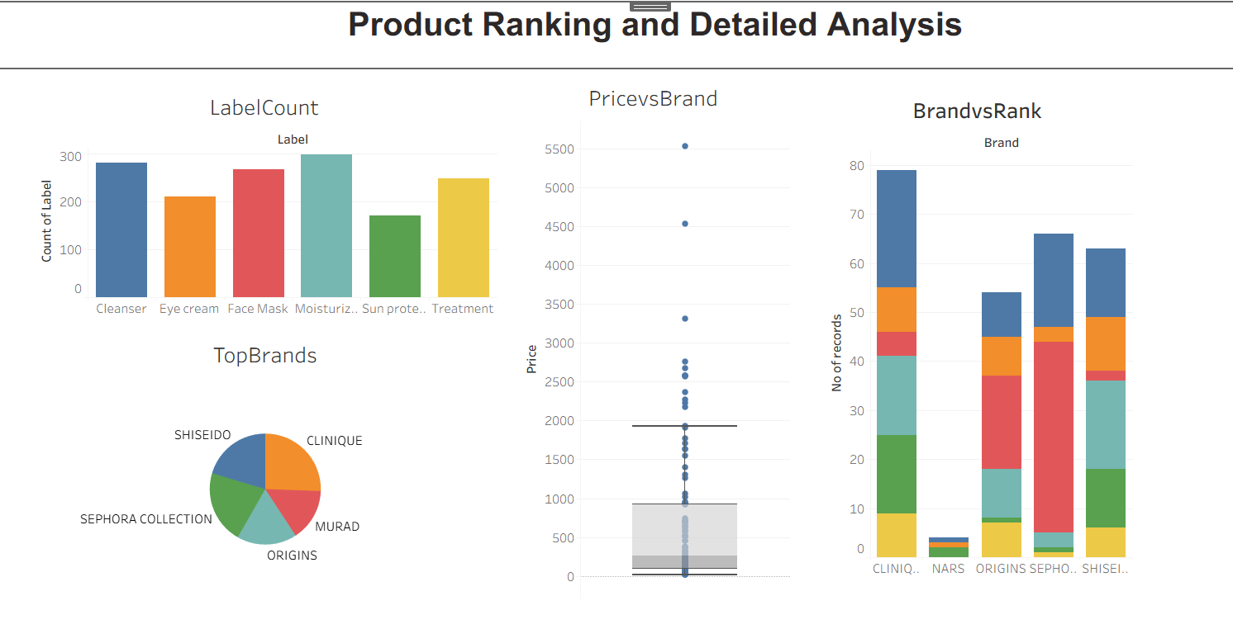**Story:**

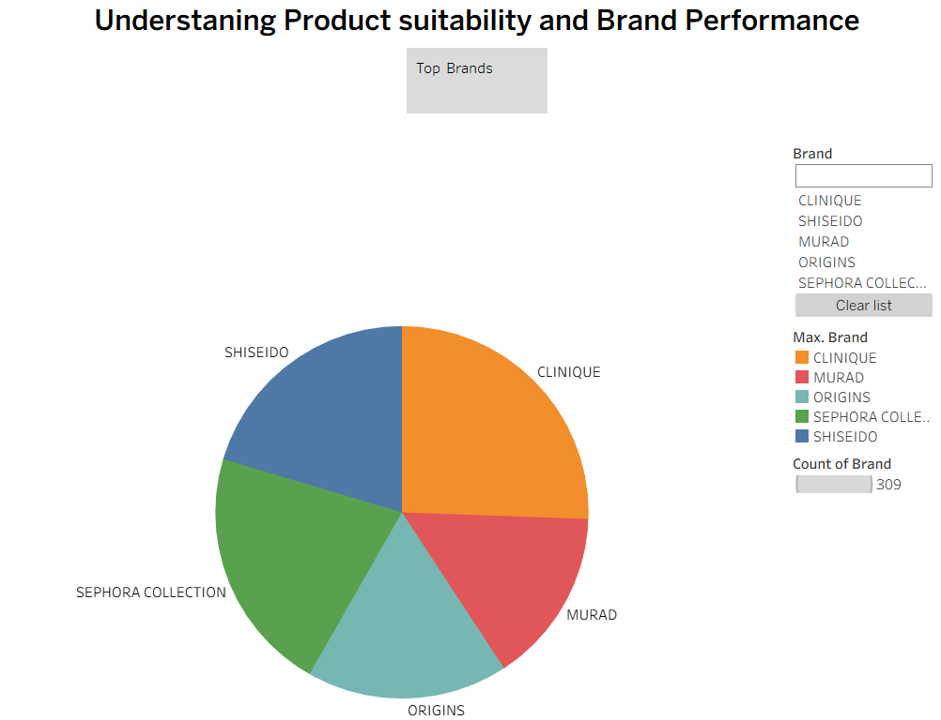

**8. ADVANTAGES & DISADVANTAGES**

**Advantages**

1. **Data-Driven Decisions** – Helps brands make informed marketing and product choices.
2. **Visual Clarity** – Tableau provides clear, interactive dashboards that are easy to understand.
3. **Trend Tracking** – Identifies emerging cosmetic trends and consumer preferences quickly.
4. **Targeted Insights** – Breaks down data by region, age, and gender for better segmentation.
5. **Improved Strategy** – Enhances product development and campaign planning using real-time insights.

**Disadvantages**

1. **Data Dependency** – Insights are only as good as the quality and completeness of the data.
2. **Limited Predictive Capability** – Tableau is great for visualization but not ideal for advanced forecasting.
3. **Requires Basic Tableau Skills** – Users need some knowledge of Tableau to interact fully with dashboards.
4. **May Miss Qualitative Factors** – Trends driven by emotion or culture may not be captured fully in data.
5. **Static Data Sources** – Without automation, dashboards need manual data updates.

### **9.Conclusion**

This project helps cosmetic brands understand trends and consumer behavior using clear, interactive Tableau dashboards.  
It supports better decision-making through visual insights based on real data.

**10.Future Scope**

-Future enhancements could include real-time data integration

-Predictive analytics

-AI-driven product recommendations for deeper insights.

**11. APPENDIX**

- Source Code: Available on request / GitHub

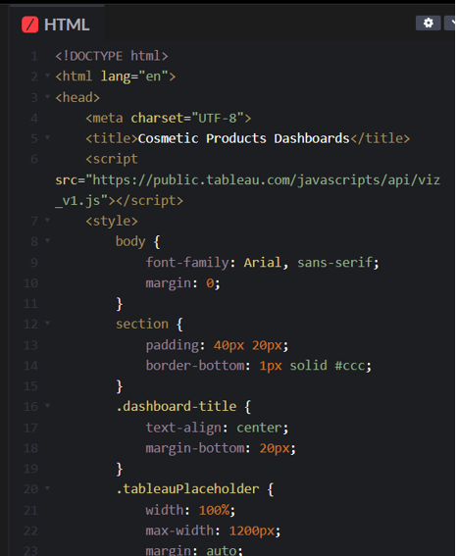

**-Dataset**: Cleaned CSV file with product & sales metrics

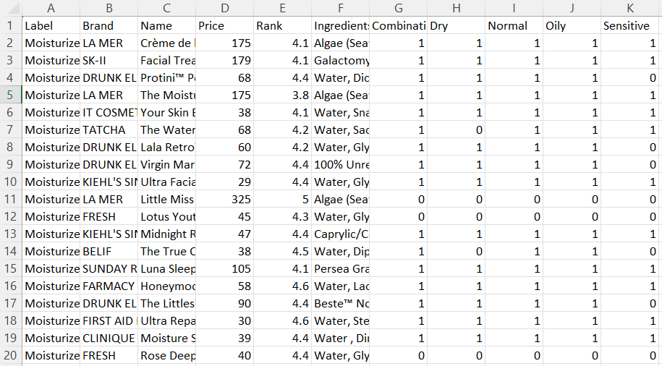

**-Project Demo:**

Watch the cosmetics insight project demo here:

<https://drive.google.com/file/d/1quTu-BEOgwqqOI0Kx45MYPkLDDEYX6iS/view?usp=sharing>